 | 10th International Conference on Short and Medium Span Bridges  Quebec City, Quebec, Canada,  July 31 – August 3, 2018 | 

THE STRUCTURAL HEALTH MONITORING SYSTEM AND EXPANSION JOINTS OF MONTREAL’S NEW CHAMPLAIN BRIDGE
Malekzadeh, Masoud^{1,3}, Moor, Gianni² and Baillés, Borja¹
¹ mageba International, USA
² mageba USA, USA
³ mmalekzadeh@mageba.net
Abstract: The design of the New Champlain Bridge, currently being constructed in Montreal, Quebec, Canada, is based on a specified design life of 125 years. In order to minimize the structure’s life-cycle costs during its long service life, highly durable key components and state-of-the-art technology are being used in its construction. This is illustrated with respect to the structure’s expansion joints, and the structural health monitoring (SHM) system that will optimize bridge inspection and maintenance activities.

INTRODUCTION
Canada’s largest current bridge construction project involves the building of a New Champlain Bridge in Montreal to replace the existing 1962 structure of the same name. The existing bridge carries approximately 160,000 vehicles per day across the St. Lawrence River. The New Champlain Bridge, expected to be completed December 1st, 2018, will have a length of 3,400 m, including a cable-stayed structure with a main span of length 240 m. The bridge’s superstructure is designed as three parallel structures, including two three-lane corridors for vehicular traffic and a two-lane transit corridor for a planned light rail transit system. The bridge will also include a path for pedestrians and cyclists. The cable-stayed structure’s single tower, of height 160m above the water, consists of twin columns supporting the superstructure’s separate parts.


Figure 1: Representation of the New Champlain Bridge (Credit: Infrastructure Canada)
The new bridge is being built as the main element of a $4.2 billion project which also includes the new Île-des-Soeurs Bridge. A consortium consisting of SNC-Lavalin, ACS and Hochtief is responsible for design, construction, financing, operations, maintenance and rehabilitation of the associated infrastructure, under a public-private partnership agreement with the Government of Canada. Overall design and construction is being undertaken by SNC-Lavalin, Dragados Canada, Flatiron Constructors Canada and EBC Inc., with design of the New Champlain Bridge the responsibility of SNC-Lavalin, TY Lin International and International Bridge Technologies. The Owner’s Engineer is headed by Arup Canada, and Independent Engineer services are provided by Stantec and Ramboll. The expansion joints and structural health monitoring (SHM) system selected for use by the design team are described in the following sections.

THE BRIDGE’S EXPANSION JOINTS
Modular joints are required at eight bridge axes, including both the west and east abutments. The number of gaps and longitudinal movement capacities of the joints are summarized in Table 1. Local Partners, GoodCo Z-Tech, helped supply WA, EA and E07.
Table 1: Overview of modular joints required
Axis | No. of gaps | Nominal SLS movement * (mm)
WA | 4 | 320
W21 | 8 | 640
W15 | 9 | 720
W09 | 10 | 800
W02 | 10 | 800
E02 | 9 | 720
E07 | 7 | 560
EA | 3 | 240
* Note: This nominal SLS movement capacity of 80 mm per gap (per seal) exceeds the actual SLS movement requirement at each axis, as the joints will be installed with a presetting to enable them to facilitate larger ULS closing movements.
The Tensa-Modular expansion joint (Figure 2) selected for use can facilitate very large longitudinal movements, and offers great flexibility, being also able to accommodate transverse and vertical movements, and rotations about all axes. Modular expansion joints divide the total movement requirement of the superstructure among individual, smaller gaps. The gaps are separated by so-called “centerbeams”, which create the driving surface (with so-called “edgebeams” at each side of the joint) and which are supported at regular intervals by support bars underneath. The gaps are made watertight by means of rubber seals. Tensa-Modular is a modular joint of the single support bar type (with every support bar supporting all centerbeams), with pre-stressed, free-sliding, bolted stirrup connections between centerbeams and support bars (see Figures 3 to 5). Rubber control springs, positioned in sets below the centerbeams, coordinate the movements of the centerbeams. This elastic system avoids constraint forces and reduces the effects of loading on the joint, extending its service life.

Figure 2: A modular expansion joint, viewed from above, showing the centerbeams and edgebeams that form its driving surface
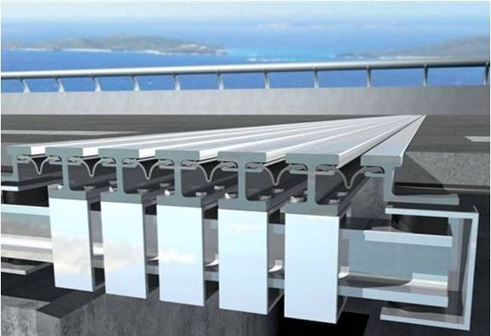
Figure 3: A Tensa-Modular expansion joint (cross section at a support bar), showing stirrup connections to centerbeams
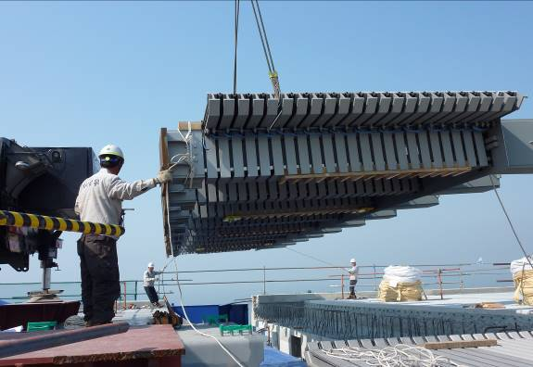
Figure 4: Installation of a Tensa-Modular expansion joint in a concrete bridge deck
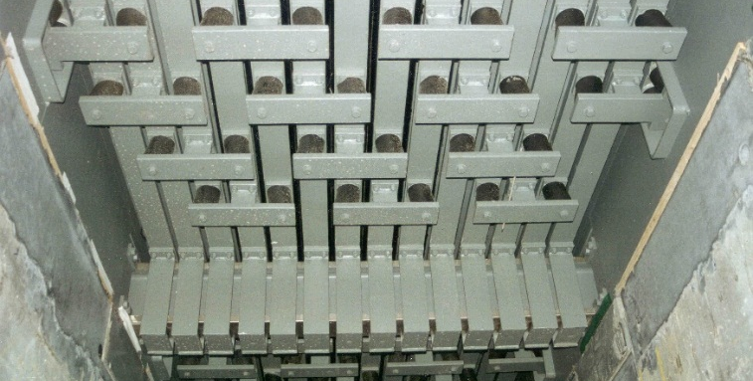
Figure 5: An installed Tensa-Modular expansion joint, viewed from below
Since the bridge is being constructed with separate superstructures for eastbound and westbound road traffic, two expansion joints will be installed at each axis, one per carriageway. The lengths of the individual expansion joints range between 17.5 m and 26.8 m. Design and manufacture of the expansion joints, for a design life of at least 30 years and to incorporate a specified seismic performance, is primarily in accordance with the Canadian Highway Bridge Design Code CAN/CSA-S6 (CSA 2014) and AASHTO LRFD Bridge Construction Specifications (AASHTO 2004), with welding in accordance with CAN/CSA-W59 (CSA 2013) and galvanizing per ASTM A123 (ASTM International 2017) and ASTM A153 (ASTM International 2016). The design of the joints, as illustrated in Figure 6, shall prevent damage by snow clearing vehicles, with vertical steel plates to the surface of the fully concreted joint anchorages and with the surface of the joint five millimetres below the connecting surfacing. Barrier plates shall also be provided for each expansion joint axis, enabling each barrier to remain continuous and functional as the deck movement gap opens and closes.
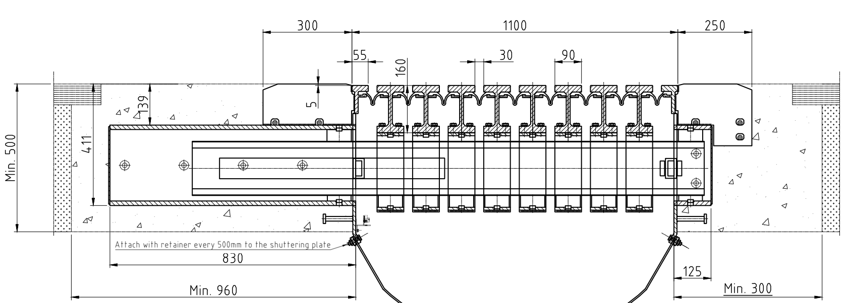
Figure 6: Typical cross section of a nine-gap joint

2.1 Laboratory testing
As described by Spuler et al. (2012), the total life-cycle costs of a bridge’s expansion joints – including in particular for maintenance and replacement and impacts such as traffic disruption during replacement works – are typically many times the original supply and installation costs, making those original costs “insignificant” in that context. It is thus very important that adequate attention and expenditure are devoted to the selection of well-designed, high-quality joints. This can be ensured, to a large extent, by evaluating the laboratory testing to which the expansion joint type has been successfully subjected.
In North America, standards published and promoted by the American Association of State Highway and Transportation Officials (AASHTO) have taken on a leading role in terms of testing requirements for modular joints in particular, with highly demanding testing defined to determine an expansion joint’s suitability in a number of key areas. The 2002 report Performance Testing for Modular Bridge Joint Systems, published by the Transportation Research Board of the National Research Council, was issued as Report No. 467 of the National Cooperative Highway Research Program (NCHRP) (Transport Research Board 2002), and was based on research which was sponsored by AASHTO in cooperation with the Federal Highway Administration, United States Department of Transportation. NCHRP Report 467 includes specifications for various prequalification tests, including the Opening Movement and Vibration (OMV) test, the Seal Push-out (SPO) test and extensive fatigue testing (all described below), which are included in Appendix A19 of AASHTO’s aforementioned LRFD Bridge Construction Specifications. The Tensa-Modular expansion joint selected for use on the new Champlain Bridge was successfully subjected to all this testing, providing great confidence to the engineers who are responsible for the bridge’s long-term performance.

2.1.1 Testing of long-term opening/closing movements and resistance to traffic-induced vibrations
The Opening Movement and Vibration (OMV) test (Figure 7) is carried out on a full-scale specimen of the modular joint type which is to be prequalified. It simulates, on the one hand, the opening (and closing) movements that can be expected to occur during a 75-year lifetime due to daily thermal cycles (i.e. one opening and closing cycle per day) – and thus features 27,400 cycles. At the same time, the test simulates the vibrations caused by traffic, with a 33 kN force applied to a centerbeam at high frequency for the entire duration of the opening movement testing. Inspection of the tested expansion joint after completion of the test allows the ability of the expansion joint to withstand these principal impacts to be evaluated.
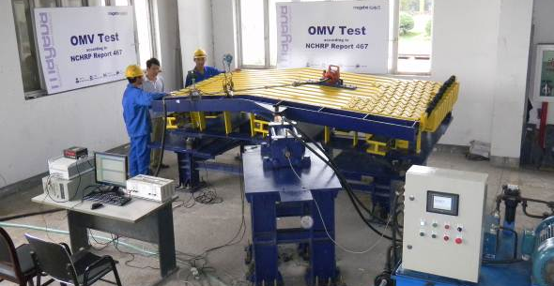
Figure 7: Opening Movement and Vibration (OMV) Test per NCHRP Report 467

2.1.2 Testing of long-term seal strength and watertightness
Following completion of the OMV test, the Seal Push-out (SPO) test (Figure 8) is carried out. This test assesses the strength of the connection of the elastomeric seals to the centerbeams which support them, and thus indirectly tests the ability of the joint to remain watertight. Since the SPO test is carried out on the same joint which has already been subjected to the rigors of an OMV test, it simulates the weakened condition with respect to movements that a seal may exhibit after many years of service, making it a more demanding and a more realistic test of performance and durability.
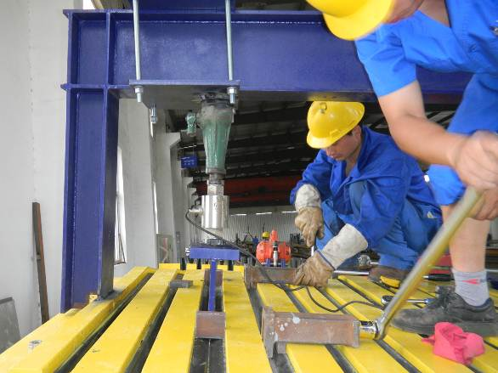
Figure 8: Seal Push-Out (SPO) test in accordance with NCHRP Report 467

2.1.3 Fatigue testing
Fatigue testing of modular expansion joints is also specified in AASHTO’s LRFD Bridge Construction Specifications, Appendix A19, with the testing based on another, similarly established NCHRP report, No. 402 (Transport Research Board 1997). This presents a practical test procedure for the determination of the fatigue resistance of critical details in the joint’s construction. The onerous testing required simulates the fatigue-inducing movements and stresses of a service life on a full-scale section of a joint which contains all critical members and connections. It involves the subjecting of expansion joint specimens to an enormous number of load cycles, and its complexity increases with the complexity of the expansion joint itself. For a highly developed and particularly flexible type of modular joint such as Tensa-Modular, fatigue testing can be especially demanding.
Testing was carried out at America’s leading institute in this field, the ATLSS Engineering Research Center of Lehigh University, Pennsylvania (Figures 9 and 10). After extensive discussions with ATLSS, considering the specifications of various American states, it was concluded that testing should consist of six million load cycles for each specimen – twice the figure of three million which might otherwise be considered based on the relevant S-N curve (which plots stress [S] against number of cycles to failure [N]). The number of cycles was doubled in this way in order for the statistical probability of a value falling above the S-N curve, and thus within the “infinite life regime (where failure will not occur after any number of cycles), to increase from 50% to 95% - a much higher degree of certainty. In relation to the fatigue testing of modular expansion joints, this factor of two is specified, for example, by Washington State Department of Transportation, one of America’s leading authorities in this field.
In accordance with AASHTO requirements, at least ten S-N data points are required to confirm that values consistently fall above the appropriate S-N curve. In the case of the Tensa-Modular joint, the test specimens were tested under constant amplitude fatigue loading at a nominal stress range of 110 MPa (16 ksi), corresponding to the constant amplitude fatigue threshold (CAFT) for AASHTO Category B (much better than the Category D specified by the standard in the absence of such testing). The testing was completed successfully, with the fatigue resistance of all details verified by testing of ten specimens, each subjected to six million load cycles without any fatigue cracking.
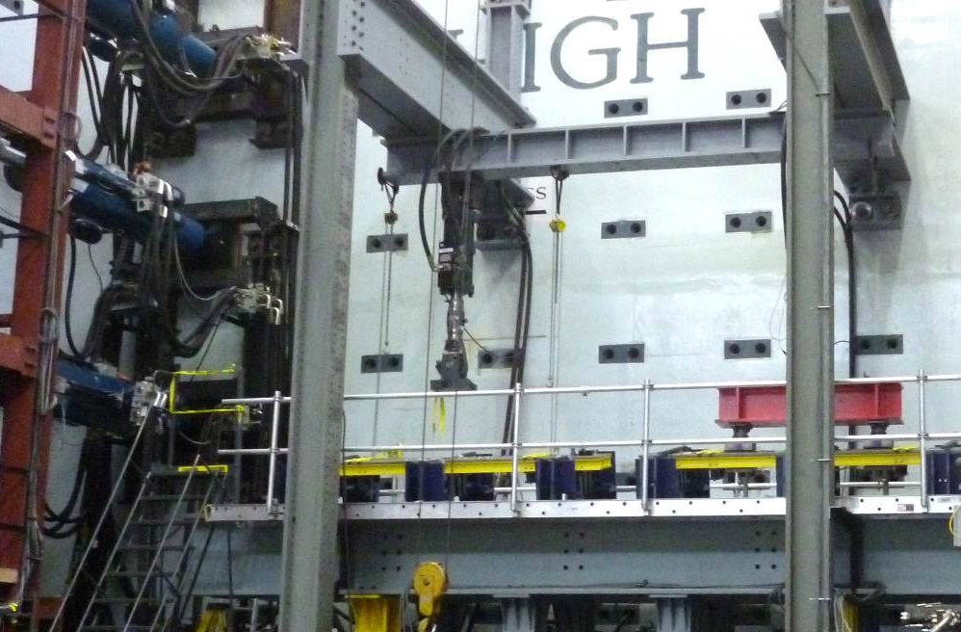
Figure 9: Fatigue testing of Tensa-Modular joint – test rig at ATLSS / Lehigh University
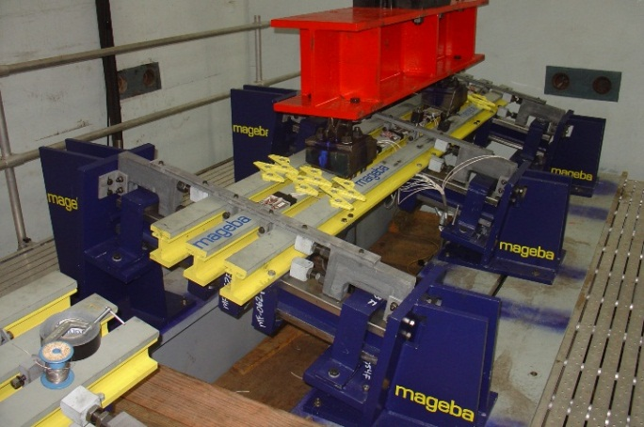
Figure 10: Fatigue testing of Tensa-Modular joint – one test specimen

2.1.4 Seismic testing
It is clearly sensible for owners of bridges in seismically active areas to be satisfied, before investing in and installing a particular type of modular expansion joint, that the joint can be expected to survive an earthquake of a specified intensity. But even if the bridge is in a non-seismic area, evidence that a specific type of joint has survived extreme seismic testing can provide great confidence in the joint’s quality, strength and durability.
The Tensa-Modular expansion joint, for example, has been successfully tested in accordance with the testing protocols of the California Department of Transportation (Caltrans). A full-scale modular joint with seven gaps and four support bars was connected to powerful actuators which would cause large, rapid longitudinal and transverse movements (Figure 11). A series of 17 tests was carried out, with varying conditions and requirements. For example, one test consisted of ten movement cycles with a velocity of 1000 mm/second, with longitudinal movements or 450 mm and transverse movements of +/- 250 mm arising, and with rotations about every axis. These factors varied for the other tests, allowing an overall picture of the performance of the joint during a range of seismic events to be assessed.
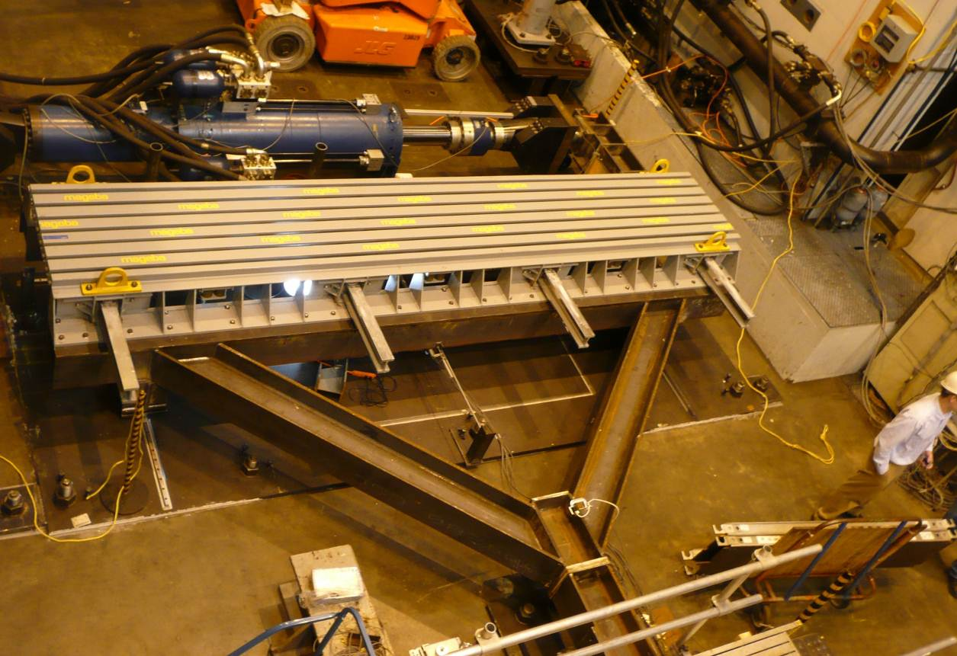
Figure 11: View from above of seismic testing as carried out per CALTRANS protocols

THE BRIDGE’S SHM SYSTEM
A permanent Robo-Control SHM system is currently being installed, covering both the new Champlain Bridge and the new Île-des-Soeurs Bridge. This system will provide, on an ongoing basis, instant data which will enable the bridge’s performance, maintenance and rehabilitation to be optimized and its service life to the extended. When fully installed, in accordance with a schedule that is dictated by the bridge’s construction process, it will incorporate over 200 sensors, as follows:
- 138 strain gauges (54 embedded and 84 glued)
- 36 displacement sensors (28 at expansion joints, 8 at bearings)
- 13 tri-axial accelerometers (on tower columns, piers and superstructures)
- 6 tilt meters (on tower columns and piers)
- 18 corrosion sensors
- Global Positioning System (GPS) units (one at tower base, two at tops of tower columns, one at base station)
- 2 weather stations (top of tower and superstructure of main span)
- 2 pyranometers (tower columns)
- 18 temperature sensors (8 for pavement, 10 for structure)
A number of sensors – those embedded in the structure’s concrete – have already been installed in late 2016 (Figure 12), with the remainder to be installed following concreting and completion of the structural elements to which they are to be externally connected.
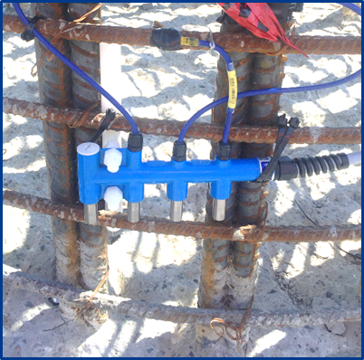
Figure 12: Corrosion sensors (embedded)
Figure 13 shows a view of the system’s Dashboard - the user interface which provides authorized users with remote access to system data, requiring only an internet connection and a password. An example of the data that can be provided by such systems (in this case, correlating temperature to bridge deck movements, both absolute and accumulated) is shown in Figure 14. All data can also be exported in tabular form for evaluation and analysis.

Figure 13: A monitoring system’s user interface on the internet
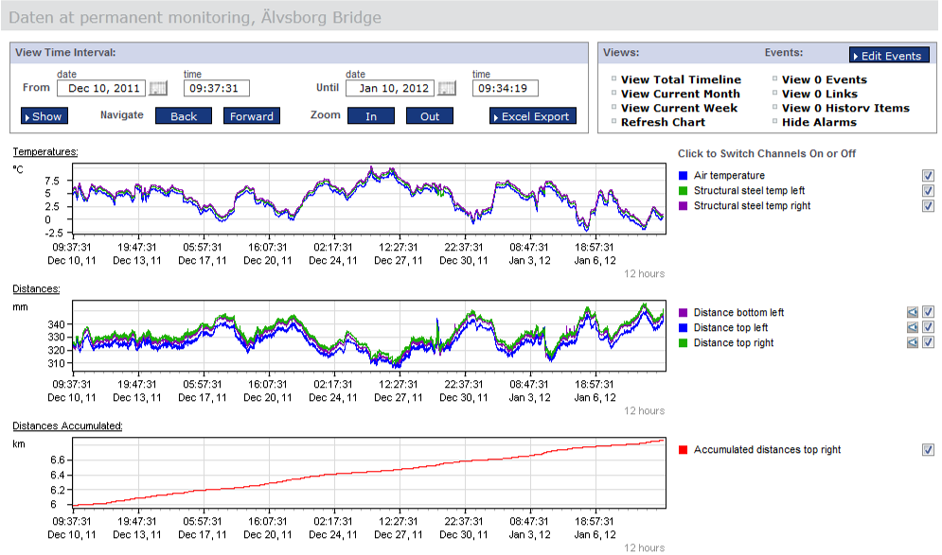
Figure 14: Graphical presentation of typical measured data
Analysis of the recorded data can include, for example, the use of histograms (Figure 15) showing the distribution of measurements (number of times each value arose during a given period), and regression models (Figure 16) showing the time evolution of movements or other data, both before and after the elimination of environmental effects.
Figure 15: A histogram presenting the frequency of measurement of specific data values such as displacements (typical)
Figure 16: A regression model is used to eliminate environmental effects from recorded data (above), facilitating easier analysis (e.g. identification of anomalies) of the adapted data (below)

REFERENCES
American Association of State Highway and Transportation Officials (AASHTO). 2004. AASHTO LRFD Bridge Construction Specifications, SI Units, 3rd Ed., Washington, DC, USA.
ASTM International. 2016. ASTM A153 / A153M, Standard Specification for Zinc Coating (Hot-Dip) on Iron and Steel Hardware. West Conshohocken, PA, USA.
ASTM International. 2017. ASTM A123 / A123M Standard Specification for Zinc (Hot-Dip Galvanized) Coatings on Iron and Steel Products. West Conshohocken, PA, USA.
Canadian Standards Association (CSA). 2013. CAN/CSA-W59, Welded steel construction (metal arc welding). Toronto, Canada.
Canadian Standards Association (CSA). 2014. CAN/CSA-S6, Canadian Highway Bridge Design Code. Toronto, Canada.
Spuler, T., Loehrer, R. and O’Suilleabhain, C. 2012. Life-cycle considerations in the selection and use of bridge expansion joints, Section 4.1, p3. 18th IABSE Congress, Seoul, South Korea.
Transport Research Board. 1997. Fatigue Design of Modular Bridge Expansion Joints (NCHRP Report 402). Washington, DC, USA.
Transport Research Board. 2002. Performance Testing for Modular Bridge Joint Systems, (NCHRP Report 467). Washington, DC, USA.

